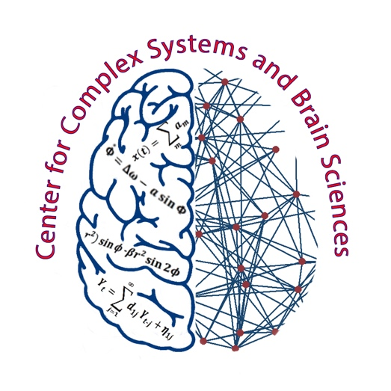

CENTER FOR COMPLEX SYSTEMS & BRAIN SCIENCES (561)297-2230
Behavioral Sciences Building, BS-12 (561) 297-3634 FAX
http://www.ccs.fau.edu

APPLICATION FOR PH.D. PROGRAM
CENTER FOR COMPLEX SYSTEMS AND BRAIN SCIENCES

Name: __________________________________________________________________________________
Home Address: Phone No. (with Area Code):
Cell:
City, State & Zip: E-mail:
___

Present School: Phone No. (with Area Code):___________________

School Address:________________________________________________________________________________

City, State & Zip_ Preferred Mentor:__________________________
(Optional) Please check here if you believe that you would qualify for minority aid program:

Previous Dates: Under- Graduate Degree Major Minor
Universities From-To Graduate

ANY ADDITIONAL INFORMATION YOU WOULD LIKE TO SHARE:

1. If you have developed specific skills associated with research (e.g., video recordings, psychophysiological recording, se of computer statistical packages, conducting computer-interfaced experiments, programming animal handling surgical procedures, brain assays), please indicate below:

2. Statement of research interest and career objectives: (attach additional page if necessary)

3. List names, addresses & phone numbers of THREE people you will be asking to send to the Center their Letters of Recommendations: (there are no special forms for these Letters)

4. Please complete the following information:
GRE Scores V: Q: Date Taken/To Be Taken:

GPA (Undergraduate): Hours:

5. Please indicate preference of professor you wish to work with: Research areas of faculty can be found at website: http://www.ccs.fau.edu.
REMINDER: SEND THE FOLLOWING INFORMATION TO: Center for Complex Systems & Brain Sciences, BS- 2, #316, Florida Atlantic University, 777 Glades Road, Boca Raton, FL 33431,ATTENTION: Rhona Frankel, Program Assistant
. Three Letters of Reference and Vita
. Copies of your GRE scores
DEADLINE FOR COMPLETED APPLICATION AND OTHER DOCUMENTS FOR THE PH.D. PROGRAM IS
JANUARY 15.
COMPLETE THE UNIVERSITY ADMISSIONS PACKET AND SEND TO:
Florida Atlantic University Graduate Admissions Office 777 Glades Road
Boca Raton, FL 33431
NOTE: OFFICIAL GRE SCORES AND TRANSCRIPTS SHOULD BE SENT TO THE GRADUATE ADMISSIONS OFFICE, NOT TO THE CENTER FOR COMPLEX SYSTEMS.

